CSC430/530 – Database Management Systems

Assignment #2 – EER to Relational Model Mapping

In this assignment, you are to map provided ER and EER diagrams into Relational Model schemas following steps described in “Lesson 5.1 - EER to Relational Model Mapping”.

1. Consider following ER diagram for a database that can be used to keep track of transport ships and their locations for maritime authorities. Note: assume port names to be unique across all states/countries and seas/oceans/lakes. Map this diagram into a relational schema and specify all the primary & foreign keys. **Describe each step of the mapping process.** Use the Steps from the lecture slides (i.e. Look at the top of each slide to see the step. Step 1 is for mapping regular entity types. Step 2 is for weak entity types. And so on according to the lecture slides). For example:

*Step 1 - mapping regular entities: SHIP, SHIP_TYPE, STATE/COUNTRY, and SEA/OCEAN/LAKE.*

* + *Regular entity SHIP mapped as SHIP relation. All simple attributes are included. Attribute “Sname”*

*is chosen as a primary key.*

* + *Regular entity SHIP_TYPE mapped as SHIP_TYPE relation. All simple attributes are included. Attribute “Type” is chosen as a primary key …*

…

*Step 4 - mapping binary 1:N relationships: TYPE, ON, IN, and HOME_PORT.*

* + *1:N relationship TYPE is mapped as a foreign key attribute “Type” in SHIP relation (“N” side) that*

*corresponds to “Type” primary key attribute in SHIP_TYPE relation (“1” side) …*

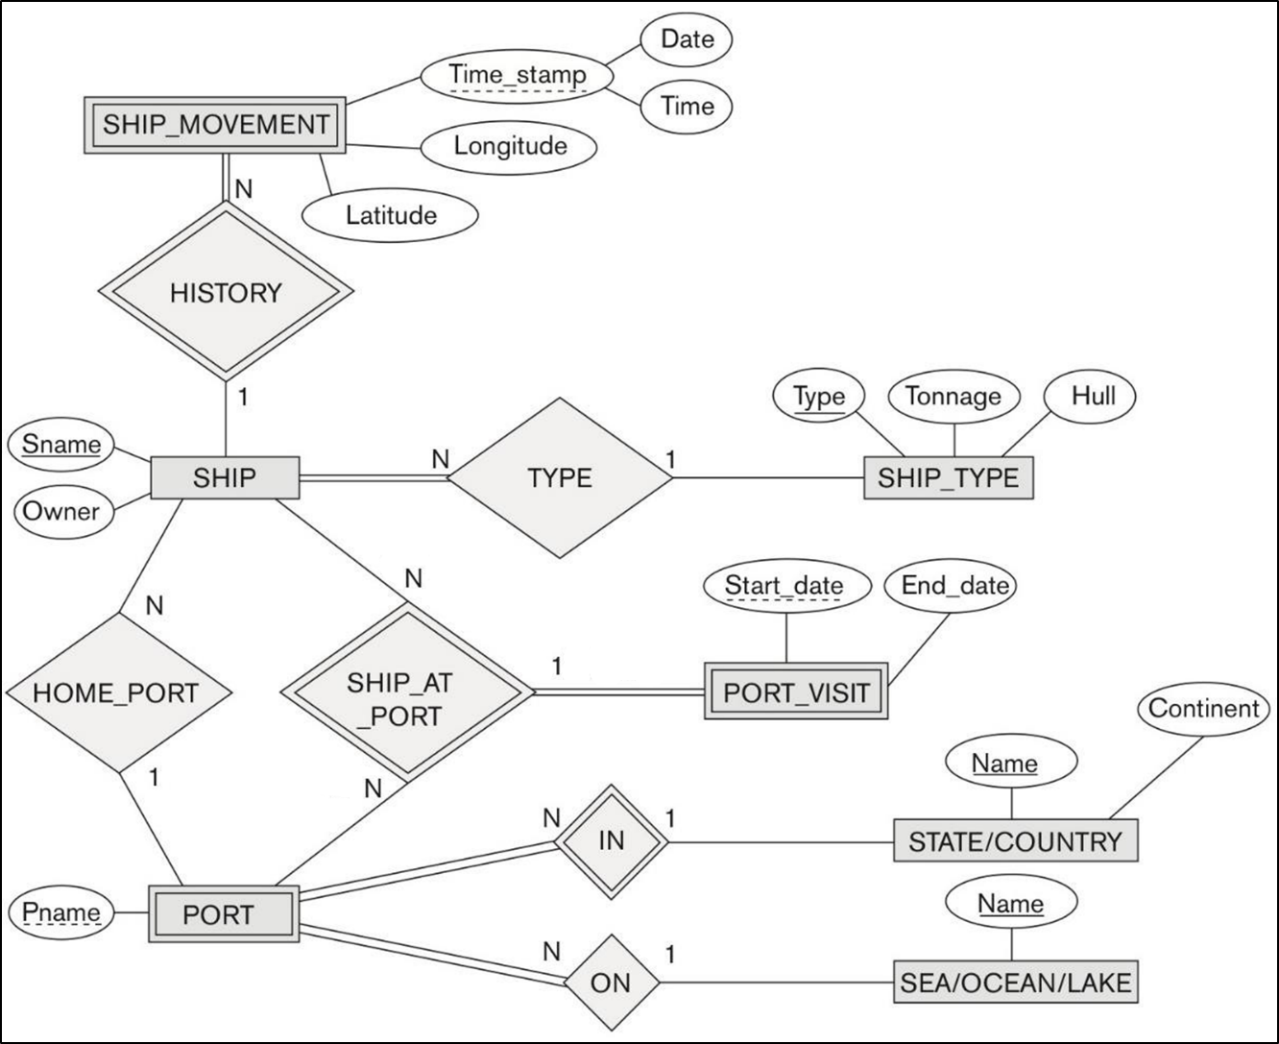

1. Consider following EER diagram for a car dealer database. Map this diagram into a relational schema and specify all the primary & foreign keys. For the VEHICLE to CAR/TRUCK/SUV specialization, pick one of the options discussed in class (8A, 8B, 8C, 8D). Justify your choice.

**Describe each step of the mapping process.** For example:

*Step 1 - mapping regular entities: VEHICLE, SALESPERSON, CUSTOMER.*

* + *Regular entity type VEHICLE is mapped as a VEHICLE relation. All simple attributes are included.*

*Attribute “Vin” is chosen as a primary key …”*

*…*

*Step 7 – mapping n-ary relationships: SALE …*

*Step 8 – mapping specializations and generalizations: CAR, TRUCK, SUV …*

